**Assessments Preparation Checklist:**

To prepare for this assessment, take help from the readings for Modules 1 through 3. Pay special focus on the section on user interface design.

**Title: User Interface Design**

Create a user interface for a desktop application that tracks the information.

* **Document the purpose, input, process, and output for the data entry form.**

The purpose of this application is to track real estate properties. This application will allow users to enter the address, description, listing agent name, seller name, square footage, acreage, availability date, and price of a real estate property. This program will calculate the down payment required, based on three approval tiers for the buyer, as shown in the table.

|  |  |
| --- | --- |
| **Credit Tier** | **Down Payment Percentage** |
| Outstanding | 2% |
| Medium | 5% |
| Poor | 10% |

The data about the properties will be stored in a database.

Users will be able to retrieve and display a list of properties based on whether the property is being sold and down payment is required. Users will be able to store the retrieved list of properties in a file. The retrieving properties will be implemented from a prebuilt database.

* **Provide a preliminary sketch of the user interface, list the controls needed on the form, and define the values for each control.**

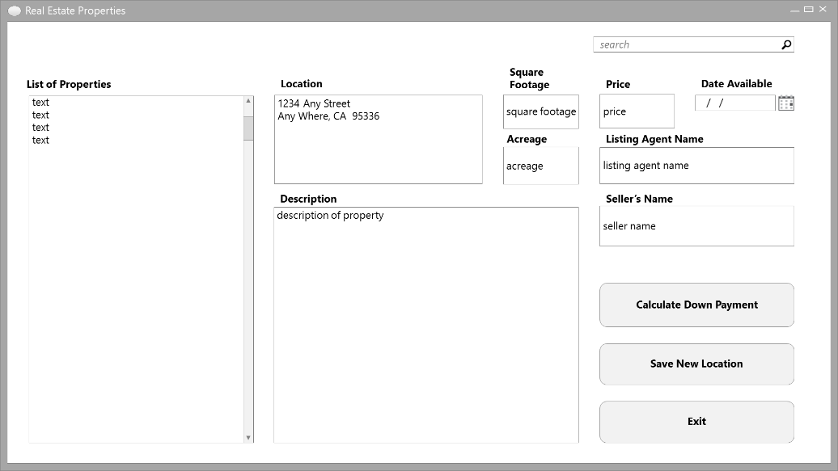

* **Document defining variables and constants. Create a document that lists the variables and constants your program will use on the data entry form. Identify the name, data type, and initial value for each.**

|  |  |  |
| --- | --- | --- |
| **Name** | **Type** | **Initial Value** |
| dblCredHigh | CONSTANT as Double | “0.02” |
| dblCredMed | CONSTANT as Double | “0.05” |
| dblCredLow | CONSTANT as Double | “0.10” |
| dblCredTier | Variable as Double |  |
| dblDwnPmtPct | Variable as Double |  |
| strPropAddr | Variable as String |  |
| strPropDesc | Variable as String |  |
| dblPropSqFt | Variable as Double |  |
| dblPropAcrg | Variable as Double |  |
| curPropPrice | Variable as Currency |  |
| strPropDtAv | Variable as String |  |
| strPropLstAgt | Variable as String |  |
| strPropSeller | Variable as String |  |
| dblPropDnPmt | Variable as String |  |
|  |  |  |

* **The company has decided that it needs to notate whether a property is commercial or residential. Modify the data entry form sketch and implement the user interface of the data entry form.**

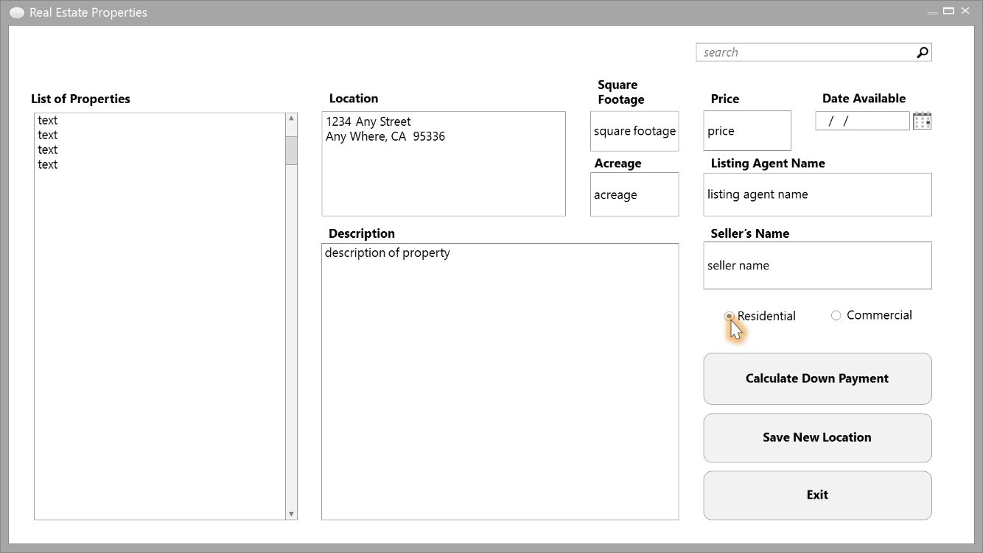

* **Design the interface for search option that allows users to select their credit level and amount of down payment they can make. The deliverable is a sketch of the search option interface and a table listing each control type and the control name.**
* **Add data validation to the data entry form.**

Valid values are shown in the table.

|  |  |
| --- | --- |
| **Property** | **Validation Rule** |
| Address | Any string, no more than 200 characters |
| City | Any string, no more than 50 characters |
| State | Any string, no more than 2 characters |
| Zip Code | A numeric string exactly 5 characters |
| Description | Any string, no more than 1000 characters |
| Listing agent name | Any string, no more than 50 characters |
| Seller name | Any string, no more than 50 characters |
| Square footage | An integer between 750 and 10,000. If a number is entered that includes decimal points, the number will be rounded before being stored. |
| Acreage | A number between 0.25 and 300 |
| Availability date | A valid date |
| Price | A decimal value between 10,000 and 3 million |

* **Draw a flowchart of a function that accepts a user credit level and down payment the user can afford and returns the highest sale price the user can afford.**

Private Function GetSalesPrice(dblCredLvl as Double, decDownPay as Decimal) decSalesPrice as Decimal

Dim HomeCost as Decimal = 0

HomeCost = GetHomeCost()

Return decSalesPrice

End Function

Private Function GetHomeCost()Sale as Decimal

Return Sale

End Function

* **Write the function signature for the function and an example of the code you would use to call it.**
* **Create a use case for the project**.

**Submission Requirements:**

Compress the following files into a single folder, using the default compression utility and submit the folder to your instructor for grading:

* Document explaining the purpose, input, process, and output for the data entry form
* Preliminary sketch of the user interface
* Document detailing the form controls, variables, and constants
* Modified data entry form sketch
* Interface design for the search option
* Flowchart of the specified function
* Document with the use case
* Source code files for all the coding

**Due:** Module 3

**Grading Weight:** 10%